FDB LAB
5
FAROOQ AHMAD
17L-4407
BEL-8A1
EXERCISE 1
- SELECT particular columns from a Table
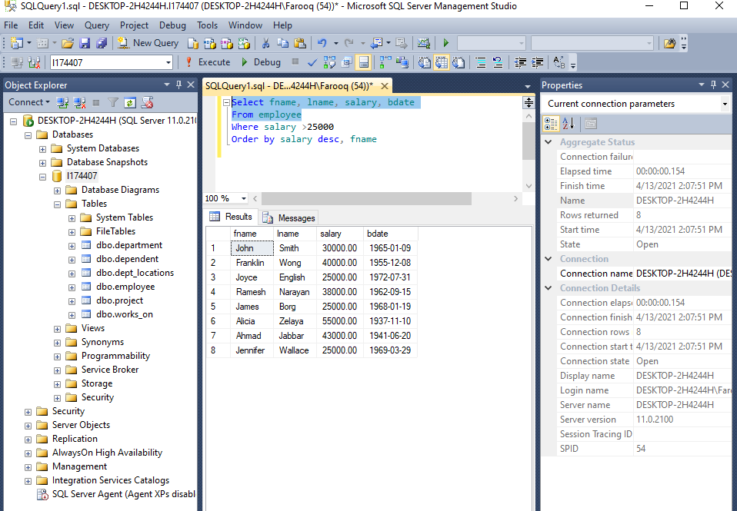

Select specific rows from a table
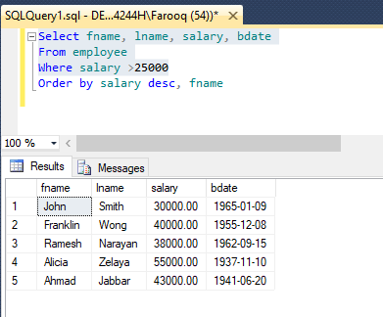

Use of order by

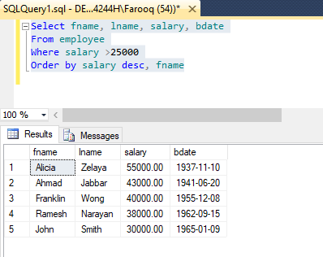
Use of DISTINCT
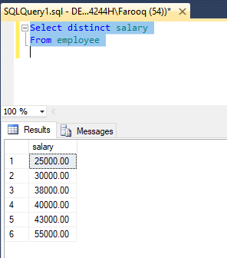

Use of built in functions
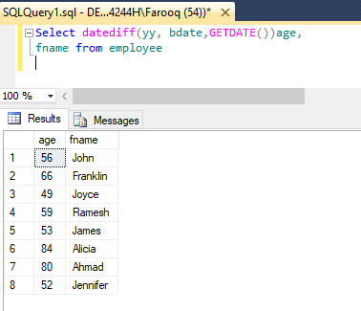

Use of like and between and null comparisons
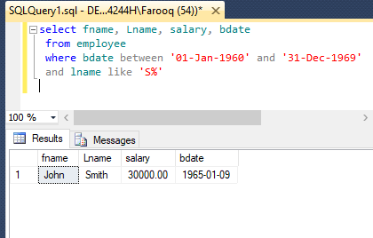
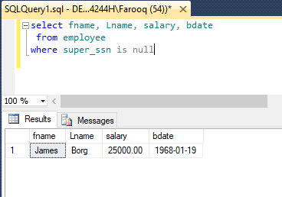
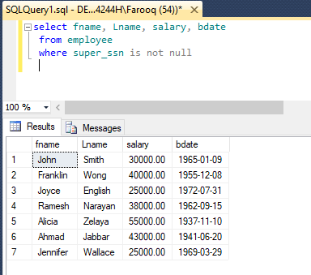

Exercise2: Practice select command from multiple tables using inner and outer joins

INNER JOIN: This join only returns rows when there is at least one match in both the tables on which the JOIN is being applied.
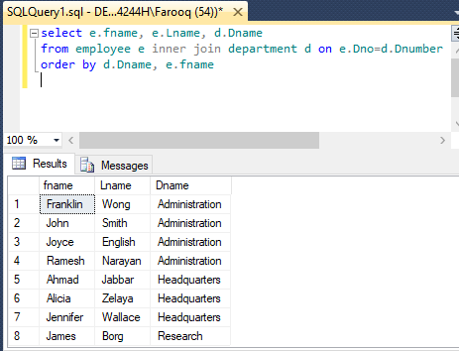
OUTER JOIN
- LEFT OUTER JOIN
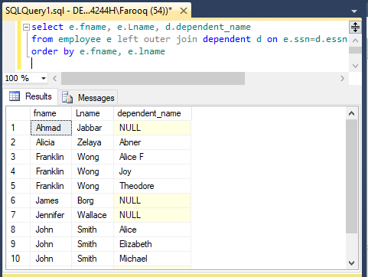
- RIGHT OUTER JOIN

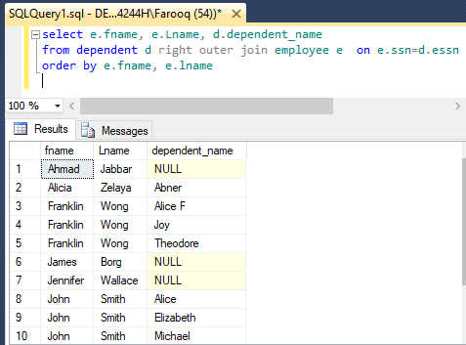

- FULL OUTER JOIN
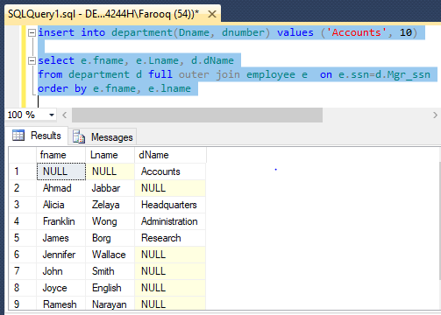

Exercise3: Practice select command using SQL Aggregate functions

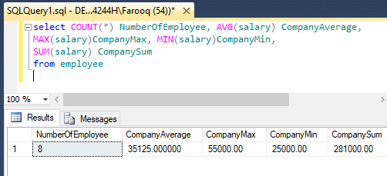

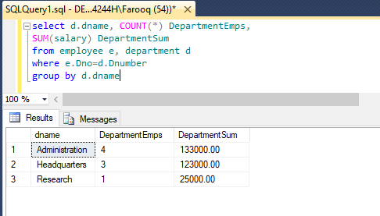
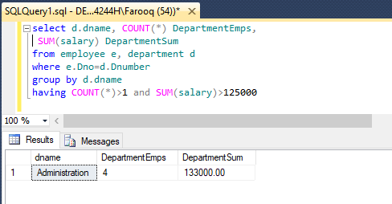

EXERCISE 4:
